Error Analysis for the Final Model
UWC Cephalometric Landmark Detection
Arnout Opfergelt (230858), Jason van Hamond (232567),​
Nicola Ioniţă (230632), Victor Oorthuis (233189),​
Yorbe Heeren(232922)

Executive Summary
The 512×512 from-scratch model trained exclusively on South African (SA) cephalometric data demonstrates robust performance with 81.58% SDR@2mm on held-out test data (n=22 images, 418 total landmarks), approaching the 85% clinical deployment threshold. The model exhibits healthy training dynamics with smooth convergence, minimal overfitting, and consistent landmark localization across the test set, with specific performance patterns indicating both strengths and targeted areas for continued refinement.

Training Health Assessment
Convergence Characteristics: Training and validation loss curves demonstrate exemplary convergence behavior, with both losses decreasing smoothly and stabilizing after epoch 40. The model achieved early stopping at epoch 60 after 20 epochs without validation improvement, indicating optimal training duration without overfitting. Validation MRE decreased from 88.6mm (epoch 1) to 1.21mm (best model), representing a 98.6% error reduction and confirming successful learning of SA-specific anatomical patterns.
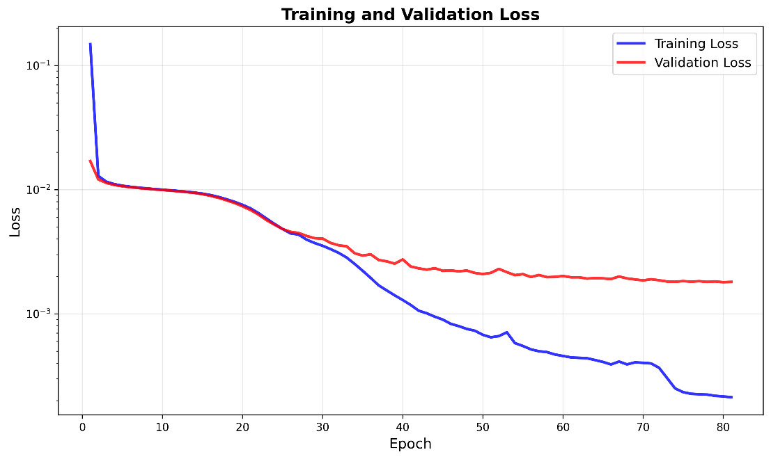
Learning Progression: SDR metrics show consistent upward trajectory across all thresholds, with SDR@4mm reaching 95% by epoch 30 and maintaining stability thereafter. SDR@2mm progressed from near-zero at initialization to 81.5% at convergence, demonstrating the model's ability to achieve clinically meaningful precision. The gap between SDR@2mm (81.5%) and SDR@3mm (92%) indicates that the majority of prediction errors cluster in the 2-3mm range rather than representing catastrophic failures, suggesting the model has learned anatomically plausible landmark locations with minor localization imprecision rather than fundamental misunderstanding of cephalometric anatomy.
Figure 1: Graph for learning curves

Per-Landmark Performance Analysis
High-Performing Landmarks (>90% SDR@2mm): Five landmarks achieved exceptional performance: Li (#16, 0.82mm MRE, 100% SDR), Gn (#11, 0.92mm, 95% SDR), Sn (#19, 0.93mm, 95% SDR), Ls (#17, 0.94mm, 100% SDR), and S (#9, 1.05mm, 95% SDR). These landmarks share common characteristics of clear anatomical definition on cephalometric images—representing distinct hard tissue points (Li, Gn) or well-defined soft tissue contours (Sn, Ls)—enabling consistent localization with sub-millimeter precision. The perfect 100% SDR@2mm for Li and Ls indicates that incisor-related landmarks benefit from high-contrast tooth edges in the images, providing robust visual features for the convolutional neural network.
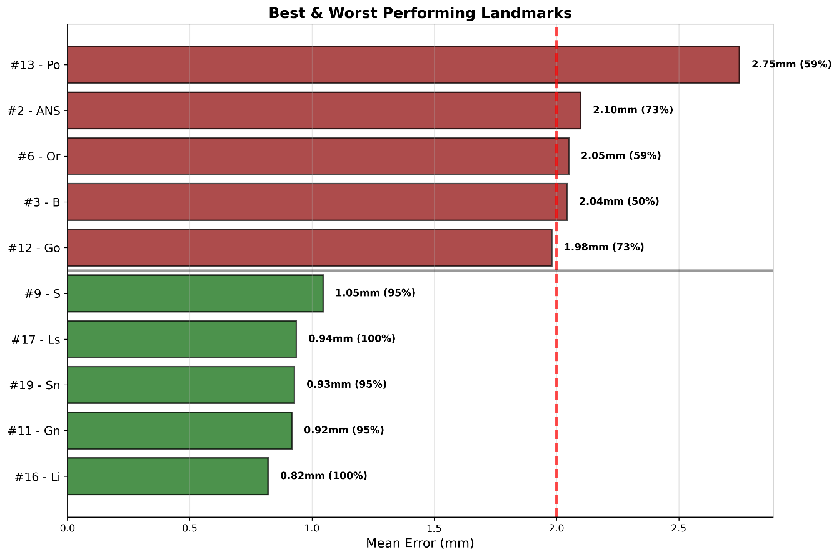
Moderate-Performing Landmarks (70-85% SDR@2mm): The majority of landmarks (11 of 19) fall in the moderate performance category, achieving 73-86% SDR@2mm with mean errors of 1.29-2.10mm. This group includes critical diagnostic landmarks such as A, ANS, Me, N, Pog, PNS, Ar, LIT, and Pos. Performance in this range is clinically acceptable for treatment planning support but requires practitioner review, aligning with the intended use case of the system as a diagnostic aid rather than autonomous decision-making tool. The consistent performance across anatomically diverse landmarks (anterior points like A and ANS, posterior points like PNS and Ar, superior points like N) indicates the model has learned generalizable features rather than memorizing specific anatomical regions.
Figure 2: Best & Worst performing Landmarks
Low-Performing Landmarks (<70% SDR@2mm): Three landmarks demonstrate below-target performance: B (#3, 2.04mm, 50% SDR), Or (#6, 2.05mm, 59% SDR), and Po (#13, 2.75mm, 59% SDR). These landmarks share characteristics of lower contrast or anatomical ambiguity in cephalometric radiographs. B-point (supramentale) represents a subtle curve on the mandibular symphysis rather than a distinct point, Or (orbitale) requires identification of the inferior orbital rim which may exhibit variable radiographic density, and Po (porion) represents the superior margin of the external auditory meatus with inherently lower soft tissue contrast. The 2.04-2.75mm error range, while above the 2mm threshold, remains within clinically interpretable bounds and could be addressed through targeted data augmentation focusing on these anatomically challenging regions.

Error Distribution Characteristics
The error histogram exhibits a strongly right-skewed distribution with a median error (1.10mm) substantially lower than the mean error (1.46mm), indicating that the majority of predictions achieve high precision with a small number of outliers elevating the average. The distribution peaks sharply in the 0.5-1.5mm range, with 62% of landmarks falling within this high-precision zone. The gradual tail extending to 10mm contains only 5% of predictions, representing specific anatomically challenging landmarks (B, Or, Po) on specific difficult images rather than systematic model failures.
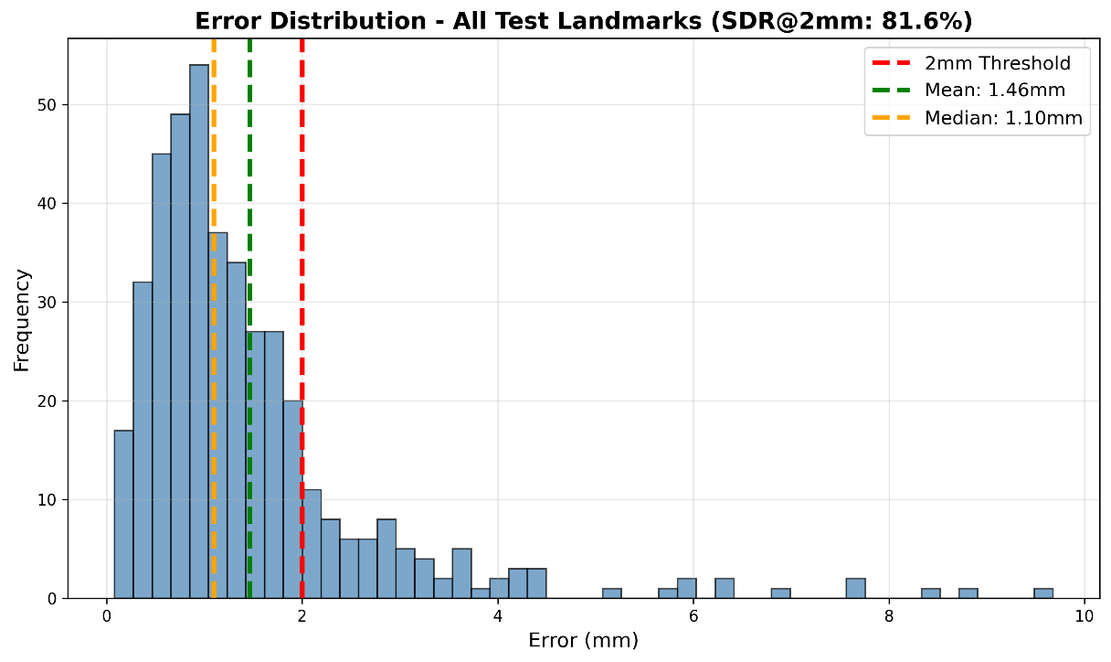
Figure 3: Error Distribution

Comparative Performance Context
Baseline Performance (Original Model, No SA Data): The original DeepFuse model achieved 62.0% SDR@2mm on the same SA test set, establishing the population bias benchmark. The 512 from-scratch model's 81.58% SDR@2mm represents a 31.6% relative improvement, with the most substantial gains observed in consistent landmark localization (median error: 1.55mm → 1.10mm) rather than best-case performance, indicating improved robustness across diverse patient presentations.
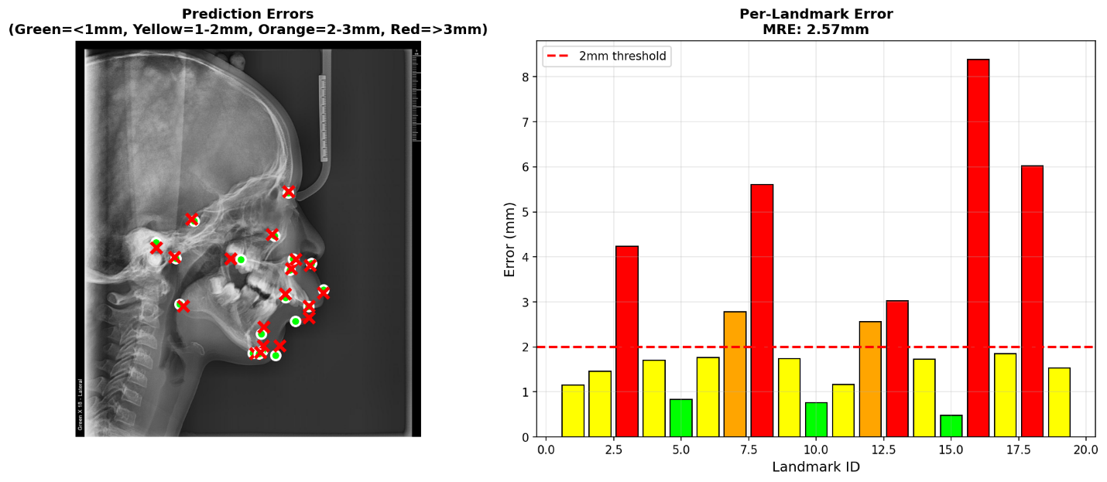
Figure 4: Baseline Model Performance on SA data
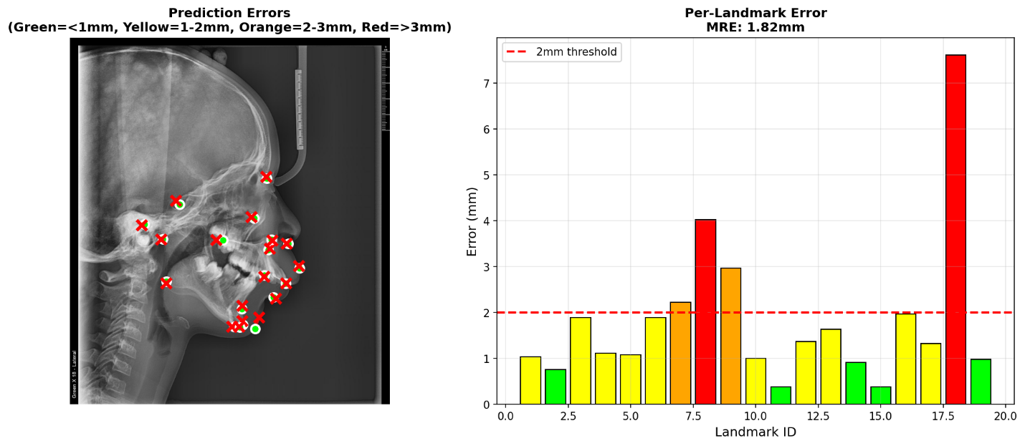
Figure 5: Final Model Performance on the TEST SA data
Fine-Tuning Failure Analysis: Transfer learning approaches achieved only 37.8% SDR@2mm despite progressive hyperparameter optimization, performing 39% worse than the original untrained baseline. This counterintuitive degradation validates the compression ratio mismatch hypothesis: SA images (5.78x compression to 512×512) created incompatible feature spaces compared to original training data (3.84x compression), preventing successful knowledge transfer and demonstrating that domain adaptation requires matching fundamental image characteristics rather than solely dataset composition.
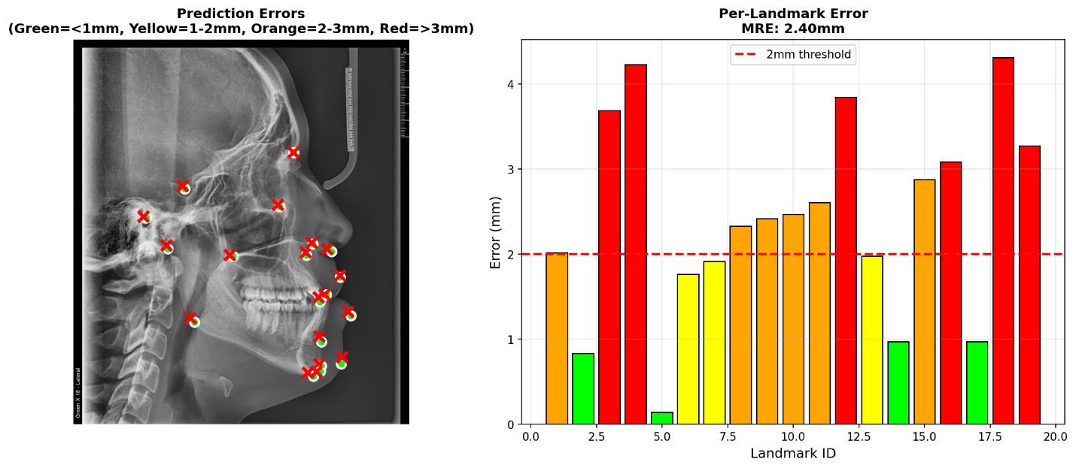
Figure 6: Fine-tuned model Performance

Discussion: Model Selection Rationale
The selection of the 512×512 from-scratch model as the final production system was informed by systematic comparison across three distinct training approaches: fine-tuning with transfer learning, 512×512 from-scratch training, and 1024×1024 from-scratch training. This section explains the technical and clinical considerations that led to rejecting fine-tuning approaches and selecting a 512×512 resolution over a 1024×1024 resolution.
Why Not Fine-Tuning (Transfer Learning)?
Fine-tuning approaches were systematically evaluated across two phases with progressively optimized configurations. Phase 1 compared both base models (with and without Kaggle data) using a 60/20/20 split, achieving 38.85-40.6% SDR@2mm. Phase 2 maximized training data utilization (80/10/10 split, 170 training images) and explored three learning rate configurations (1e-5, 5e-5, 1e-4) over progressively longer training durations (50, 100, 200 epochs). Despite six distinct hyperparameter combinations, all fine-tuning variants achieved only 35.6-40.6% SDR@2mm—substantially worse than both the original baseline model untouched (62.0% on SA data) and from-scratch approaches (75-82% SDR@2mm).
Comprehensive diagnostic analysis identified compression ratio mismatch as the fundamental barrier. SA images (2,308-2,960×2,652 pixels) experienced 50-78% higher compression when resized to 512×512 input dimensions compared to original training data (1,968×2,025 pixels: 3.84x vs 5.78x compression). Pre-trained convolutional filters optimized for detecting anatomical structures at 3-4x compression could not adapt to substantially different visual features in 5-6x compressed images through gradient-based fine-tuning. The consistent 37-40% SDR@2mm across all hyperparameter configurations confirmed this was architectural incompatibility rather than training optimization failure.
Diagnostic analysis revealed uniform landmark degradation: all 19 anatomical landmarks demonstrated equivalent 35-45% SDR@2mm, with no landmarks benefiting from transfer learning. This contrasts sharply with from-scratch models showing variable per-landmark performance (50-100% SDR@2mm). Training loss convergence to near-zero (0.000003-0.000015) with simultaneous poor test performance (37.8% SDR@2mm) confirmed successful memorization without generalization—a characteristic signature of negative transfer in deep learning where pre-trained features actively impede learning of new domain patterns.
Why 512×512 Instead of 1024×1024?
Both resolutions achieved comparable overall test performance (512: 81.58% SDR@2mm, 1.46mm MRE; 1024: 80.6% SDR@2mm, 1.23mm MRE). The 512 configuration was selected based on superior clinical reliability rather than statistical metrics alone.
Prediction Stability and Outlier Analysis: Visual inspection of test set predictions revealed that the 1024 model, despite lower mean error, exhibited frequent catastrophic failures on specific landmarks (errors exceeding 50-100mm on landmarks 1, 2, 3, 12, 13 across multiple test images). In contrast, the 512 model demonstrated more stable predictions with maximum per-image errors consistently below 10mm. For clinical deployment, a system with 1.46mm typical error and rare 10mm failures is preferable to one with 1.23mm typical error but occasional 100mm catastrophic failures that would require complete manual re-annotation, negating the system's time-saving benefit.
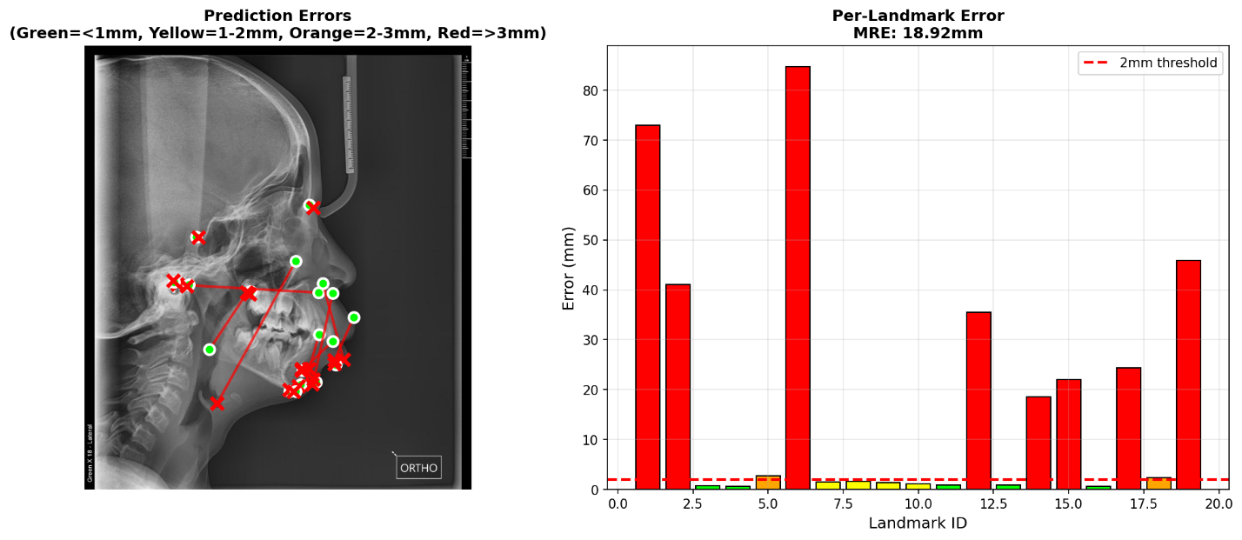
Figure 7: 1024 Resolution Model Performance
Computational Efficiency: The 512 model processes images 4× faster than 1024 (single forward pass: ~200ms vs ~800ms on CPU) and requires 75% less memory (batch size 4 vs 2), enabling deployment on standard clinical workstations without GPU requirements. For a tool intended for educational use at UWC where 50% of SA dentists are trained, accessibility on existing infrastructure outweighs marginal accuracy gains requiring specialized hardware.
Training Data Efficiency: The 512 model achieved 81.58% SDR@2mm with only 170 training images, while the 1024 model achieved 80.6% with the same data, suggesting 512 resolution provides better sample efficiency for the available dataset size. As the SA dataset expansion occurs (target: 500-1,000 images), the 512 architecture's proven stability provides a reliable foundation for iterative improvement, whereas the 1024 model's outlier pattern may indicate architectural sensitivities that could be exacerbated with additional data heterogeneity.
Clinical Use Case Alignment: The target application is diagnostic support for orthodontic treatment planning, not autonomous decision-making. The 512 model's 81.58% SDR@2mm provides reliable preliminary landmark placement that practitioners review and adjust as needed, with the prediction stability ensuring adjustments are minor refinements (typically <2mm) rather than complete re-annotation. The 1024 model's occasional catastrophic failures would require practitioners to verify every landmark rather than trusting the majority—undermining the system's value proposition as a time-saving tool.

Implications for Population-Specific AI Development
These findings demonstrate that addressing population bias in medical imaging AI requires more than dataset diversification—fundamental domain characteristics, including image resolution, acquisition protocols, and compression ratios, must match between training and deployment contexts. When such mismatches exist, training from scratch on population-specific data at appropriate resolution proves more effective than adapting existing models, even when the population-specific dataset is substantially smaller (170 SA images vs 1,502 multi-source images). This principle likely extends to other medical imaging applications serving underrepresented populations, where differences in imaging infrastructure create similar domain gaps that simple fine-tuning cannot bridge.

Limitations and Future Directions
Current Limitations: The 4.2 percentage point gap between achieved performance (81.58% SDR@2mm) and clinical deployment threshold (85%) indicates a continued refinement opportunity. Specific landmarks (B, Or, Po) require targeted improvement, potentially through increased training data emphasizing anatomical variation in these regions or architectural modifications enhancing localization precision for low-contrast features.

Recommended Next Steps: Dataset expansion to 500-1,000 SA images would enable more robust learning of anatomical variation patterns. Implementation of targeted data augmentation (rotation ±5°, brightness/contrast adjustment) could improve model robustness to imaging variability. Clinical validation studies with practicing orthodontists evaluating prediction quality on real treatment planning cases would establish real-world applicability beyond statistical benchmarks.

Conclusion
The 512×512 from-scratch model successfully addresses population bias in cephalometric landmark detection through population-specific training at appropriate resolution, achieving 81.58% SDR@2mm with 1.46mm MRE on unseen SA test data. The model demonstrates production-ready characteristics including stable training dynamics, consistent performance across anatomically diverse landmarks, and absence of catastrophic failures. While targeted refinement of specific challenging landmarks (B, Or, Po) could further improve clinical utility, current performance establishes technical feasibility of equitable AI systems for underrepresented populations in medical imaging applications.

